
INTERNATIONAL UNIVERSITY
SCHOOL OF ELECTRICAL ENGINEERING (EE)

EE091

ELECTRONIC DEVICES

LAB 1

DIODE CHARACTERISTICS

Full name:………………………………..
Nguyễn Minh Đức - ITITIU21045………………………...
Nguyễn Quang Tâm - ITITIU21304………………………..
Tôn Long Thuận - ITITIU21322………………………...

Electronics Devices Page 1 of 9
INTERNATIONAL UNIVERSITY
SCHOOL OF ELECTRICAL ENGINEERING (EE)

- OBJECTIVES

In this laboratory, you will be introduced the use of breadboard, the equipment used in this laboratory. You will also learn the behavior of diodes and rectifier circuits using diodes.

- INTRODUCTION TO THE LABORATORY

  - Breadboard

A breadboard is used to make up temporary circuits for testing or to try out an idea. No soldering is required so it is easy to change connections and replace components. Parts will not be damaged so they will be available to be reused afterward.

- Components

  - Resistors: 1K

  - Capacitors: 1uF

  - Diode: 1N4007 (or 1N4148), Zener 5V1

- Equipment

  - Function Generator

  - Oscilloscope

  - Digital Multi-meter

  - DC source

III. SEMICONDUCTOR DIODE PRELAB

Students are expected to provide calculated sheets for problem A & B as well as waveforms and set-up circuitries for problem C & D (1 & 2) in the beginning of the lab. You may use any simulation platform you wish.

IV. PROCEDURE

A. 1N4148 Diode

Build the following diode circuit:
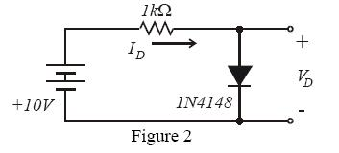

Electronics Devices Page 2 of 9
INTERNATIONAL UNIVERSITY
SCHOOL OF ELECTRICAL ENGINEERING (EE)
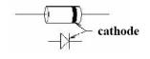

- Using the diode equation, plot the I-V characteristics for a diode with n = 2, I_{S} = 10⁻⁹ Amps and V_{r} = 26mV . Limit the current range to 0 ÷ 10 mA. Calculate the diode voltage as the power supply is varied from 0 to 10V using the steps given in Table 1.
R = 0.9904 kOhm
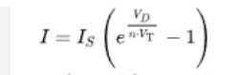

Table 1. Measurement results for simple diode circuit.

Source | Diode voltage VD, Volts |  | Diode Current ID, Ampere
voltage
VS, | Calculated | Experimented | Calculated | Experimented
Volts
0 | 0 | - 0.0612 | 0 | -61.79 x 10⁻⁵ A
0.2 | 0 | 0.1895 | 0 | 1.913 x 10⁻⁴ A
0.4 | 0 | 0.38 | 0 | 3.8368 x 10⁻⁴ A
0.6 | 0.05 | 0.4794 | 0.0001 A | 4.8405 x 10⁻⁴ A
0.8 | 0.1 | 0.5193 | 0.0001 A | 5.2433 x 10⁻⁴ A
1 | 0.15 | 0.5436 | 0.0002 A | 5.4887 x 10⁻⁴ A
2 | 0.4 | 0.5998 | 0.0006 A | 6.0561 x 10⁻⁴ A
3 | 0.67 | 0.6253 | 0.0013 A | 6.3136 x 10⁻⁴ A
6 | 1.51 | 0.6635 | 0.0041 A | 6.6993 x 10⁻⁴ A
10 | 2.5 | 0.6896 | 0.0112 A | 6.9628 x 10⁻⁴ A

For each of the voltage steps above, determine the diode current ID by measuring the voltage drop across the 1 kΩ resistor. Since the value of the resistor is known, the current flowing through the resistor can easily be calculated.

- Plot the IV characteristics of the diode. The usage of Excel/Matlab/Simulation platforms are encouraged.
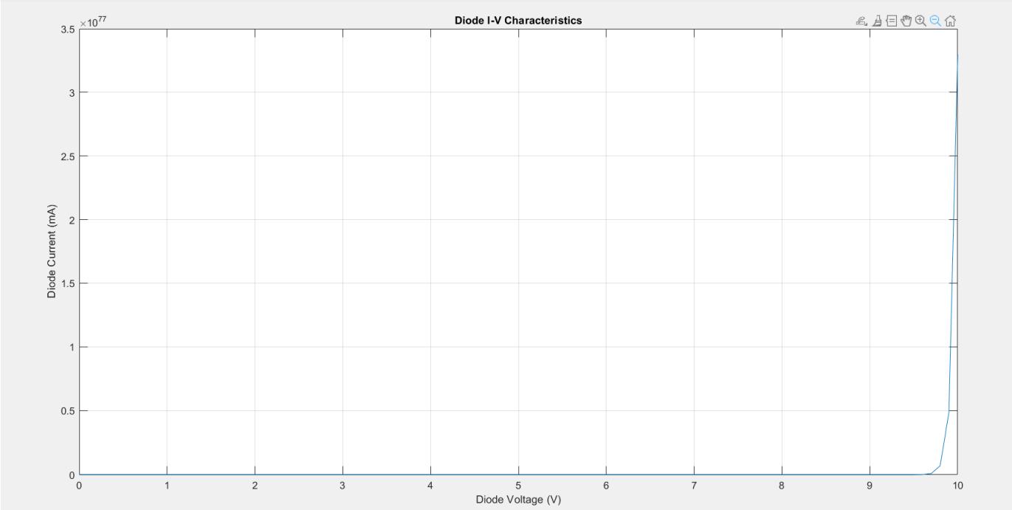

Electronics Devices Page 3 of 9
INTERNATIONAL UNIVERSITY
SCHOOL OF ELECTRICAL ENGINEERING (EE)

- Draw a tangent line to the curve at around ID = 3mA and determine the incremental resistance of the diode at this point.
r_{D} = Change in V_{D}/Change in I_{D}
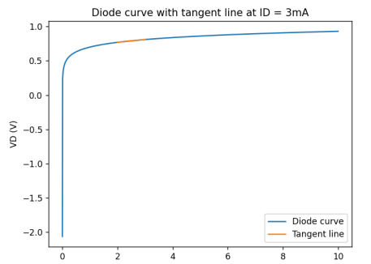

4. Compare this value of resistance to the calculated value of

(with n = 2, V_{r} = 26mV and I_{D} = 3mA ). How do these values compare?
r = n*V_{T}/I_{D} = 2*26mV/3mA = 52/3 mΩ

- Set the power supply to 10 volts and then vary the supply voltage by ±20% (8 − 12 ). Record the diode voltages, and at both points.

- Determine the Line Regulation of the diode circuit
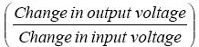

Express the results in [mV/V].

- Set the supply voltage back to its nominal value (10V). Add a 1kΩ load across the diode. Measure the drop in output voltage. Determine the load regulation
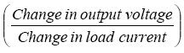

Express the results in [mV/mA]. Remember in the first case there is no load and no load’s current. By adding the resistor, you have added a load to the diode circuit. You can easily determine the load current if you know the voltage drop across the load resistor.

What is the function of the resistor in this circuit? How much current would have to flow through the diode if there was no resistor between the diode and the voltage source?

B. Zener Diode

Replace the diode in the previous circuit with a Zener diode:

 | 1K
 |  | +
 | Iz
10V |  | V
10V | 5V1 | z
 |  | -
 | Figure 3
Electronics Devices |  | Page 4 of 9
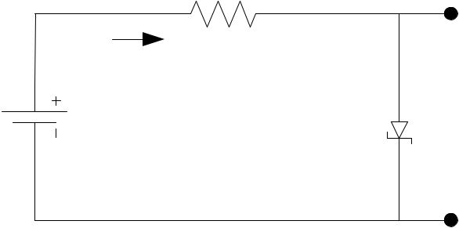
INTERNATIONAL UNIVERSITY
SCHOOL OF ELECTRICAL ENGINEERING (EE)

- Using the same technique used earlier, measure the diode voltage and calculate the diode current. Change the voltage source from 0 to 10 volts using the steps from Table 2.
V_{r} = V_{Z} + I_{D}*R
I_{Z} = I_{D} – I_{L} = [V_{R}/R]

Table 2. Measurement results for basic Zener diode circuit

Source | Diode voltage |  | Drop on resistor VR,Volts |  | Diode current
voltage | Vz, Volts |  |  |  | IZ = [VR/R]
Vs | Calculated | Experimented | Calculated | Experimented | Calculated | Experimented
Volts
0 | 0 | -0.0587 | 0 | 0.0002 | 0 | 2.0194 x 10⁻⁴
0.2 | 0.2 | 0.1883 | 0.2 | 0.0003 | 0 | 3.0291 x 10⁻⁴
0.4 | 0.4 | 0.3857 | 0.4 | 0.0009 | 0 | 9.0872 x 10⁻⁴
0.6 | 0.6 | 0.5808 | 0.6 | 0.0039 | 0 | 3.9378 x 10⁻³
0.8 | 0.8 | 0.6845 | 0.8 | 0.1029 | 0 | 0.1039
1 | 1 | 0.7104 | 1 | 0.2766 | 0 | 0.2793
2 | 1.2 | 0.7502 | 1.2 | 1.2355 | 0.2 | 1.2475
3 | 1.4 | 0.7658 | 1.4 | 2.2194 | 0.4 | 2.2409
6 | 1.6 | 0.7882 | 1.6 | 5.188 | 0.6 | 5.2383
10 | 1.8 | 0.8037 | 1.8 | 9.156 | 0.8 | 9.2447

What is the difference between this Zener diode and the other diode you measured previously? Can you tell the difference between a normal diode and a Zener diode by looking at such a chart?
- Zener Diode: Zener diodes are primarily used for voltage regulation. They are designed to operate in the reverse breakdown region, maintaining a nearly constant voltage across their terminals.
- Standard Diode: Standard diodes are often used for rectification, allowing current to flow in one direction only.

- Continue measuring the circuit, this time apply the negative voltages given in Table 3 and record the results.
Calculate the diode current (ID) using the following formula:
I_{D} = (V_{S} - V_{Z}) / R

Calculate the load voltage (Vr) using the following formula:
Vr = V_{Z} + I_{D} * R

Calculate the Zener diode current (Iz) using the following formula:
Iz = I_{D} - I_{L}

Table 3. Measurement results for basic Zener diode circuit (continued)

Source | Diode voltage |  | Drop on resistor |  | Diode current
voltage | Vz, Volts |  | VR,Volts |  | IZ = [VR/R]
Vs, | Calculated | Experimented | Calculated | Experimented | Calculated | Experimented
Volts
-1 | 0 | -0.985 | 0 | 0 | 0 | 0
Electronics Devices |  |  |  |  |  | Page 5 of 9

INTERNATIONAL UNIVERSITY
SCHOOL OF ELECTRICAL ENGINEERING (EE)

-2 0 -1.9806 0 -0.0004 0 -4.0388 x 10⁻⁴

-3 0 -2.9723 0 -0.0121 0 -0.0122

-4 0 -3.847 0 -0.132 0 -0.1333

-5 0 -4.41 0 -0.5617 0 -0.5671

-6 0 -4.681 0 -1.2859 0 -1.2984

-7 0 -4.822 0 -2.1457 0 -2.1665

-8 0 -4.902 0 -3.0657 0 -3.0954

-9 0 -4.955 0 -4.007 0 -4.0458

-10 0 -4.991 0 -4.966 0 -5.0141

What can be said about the Zener voltage for this particular Zener diode?
The source voltage is negative; therefore, diode current will be negative => The diode is reverse biased => Does not conduct current. Thus, the diode current and Zener diode current equals zero.

- Using both charts, plot the complete IV terminal characteristics for the Zener diode.

C. Half Wave Rectifier

Build the rectifier circuit shown in Figure 4.
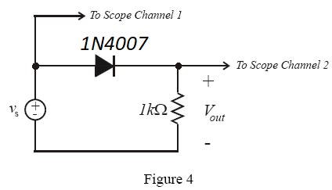

Electronics Devices Page 6 of 9
INTERNATIONAL UNIVERSITY
SCHOOL OF ELECTRICAL ENGINEERING (EE)

- Use the function generator to set up the signal source . Use the sine wave at 1000Hz with a peak amplitude of 4 volts.
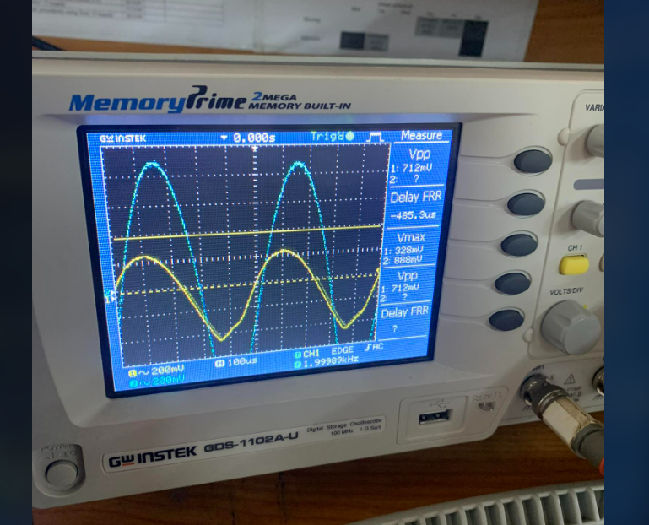
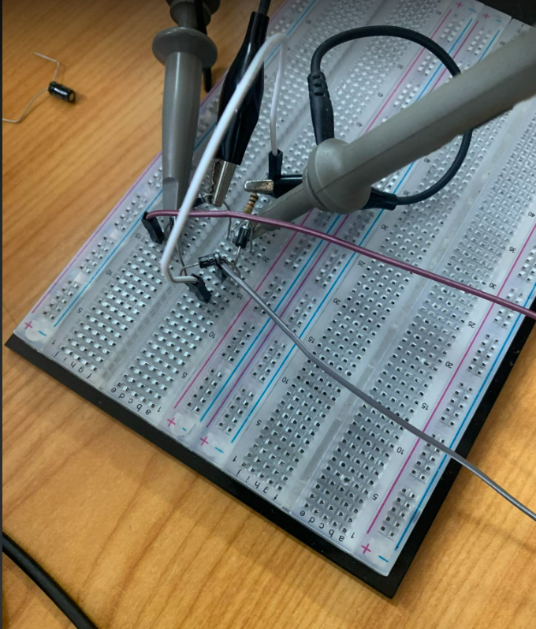

- Use the oscilloscope to display both the input and the output at the same time. Take picture of these waveforms. Does it similar to your simulated waveform?

- Yes, it does

- Use a DC voltmeter to record the input and output voltages.

- Set your oscilloscope to X-Y setting. This will display channel 1 (input) on the X-axis and channel 2 (output) on the Y-axis. This will display the transfer characteristic of your circuit. Sketch the transfer characteristic you observe and comment.
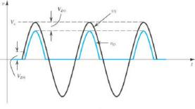

Figure 4.1: Half wave Rectifier {Sedra and Smith, Microelectronic Circuits, 5th edition}
D. Full-Wave Rectifier

A more commonly used circuit is the bridge rectifier. Build the bridge rectifier shown in Figure 5.
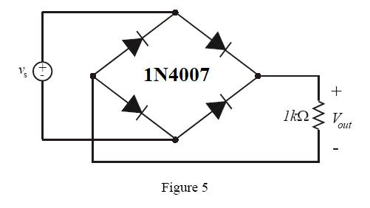

Electronics Devices Page 7 of 9
INTERNATIONAL UNIVERSITY
SCHOOL OF ELECTRICAL ENGINEERING (EE)

- Use a sinusoidal input voltage at 1000 Hz with an amplitude of 10 volts. Measure and sketch the input and output of the circuit using the oscilloscope (in normal time measurement, not X-Y mode). Take picture of these waveforms. Does it similar to your simulated waveform?
- Yes, it does

To measure the output voltage Vout , connect channel-1 of the oscilloscope to the positive end of the resistor (Va). Connect channel-2 of the oscilloscope to the negative end of the resistor (Vb) while connecting the common ends of both channels to Vref. Display both channels and select “add” mode on the oscilloscope. This will give you Va + Vb. Use the “Invert Channel-2” option to get Va – Vb which is equivalent to Vout.

- Now add a capacitor 1µF parallel to the output as shown in Figure 6. (Be careful with the polarity of the capacitor), sketch the new output. Explain in detail how the capacitor works in the circuit.
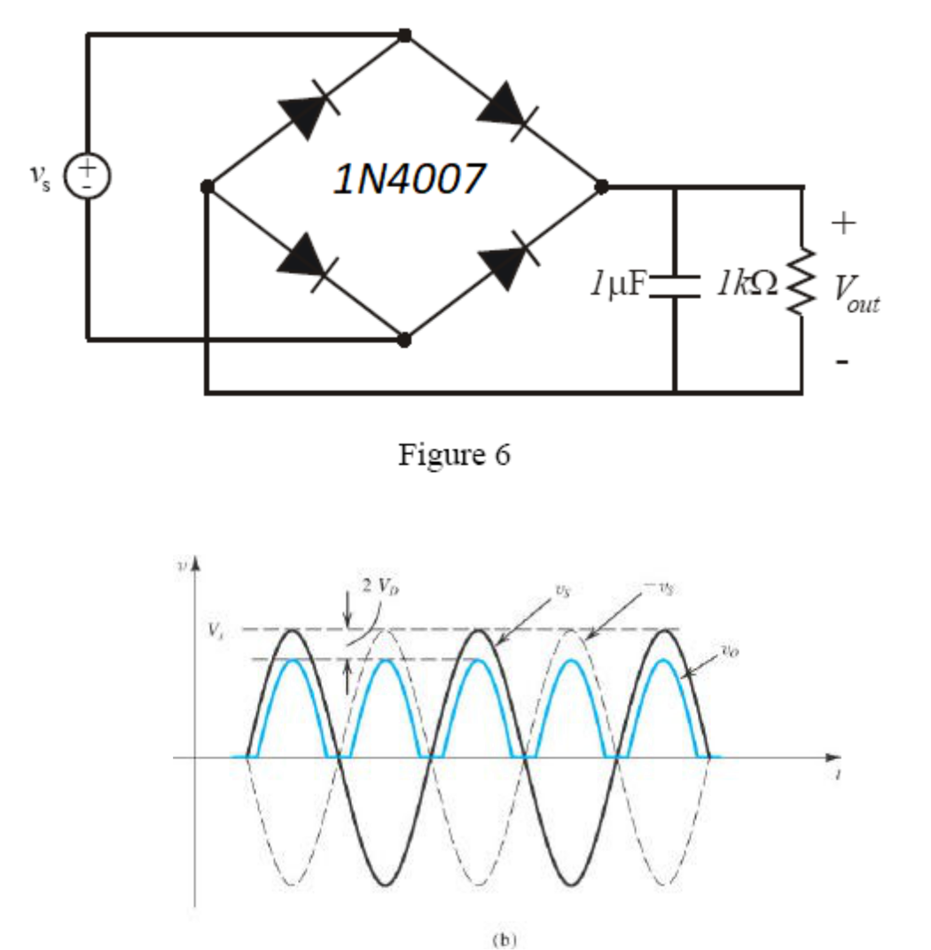

Figure 7: Full wave Rectifier {Sedra and Smith, Microelectronic Circuits, 5th edition}
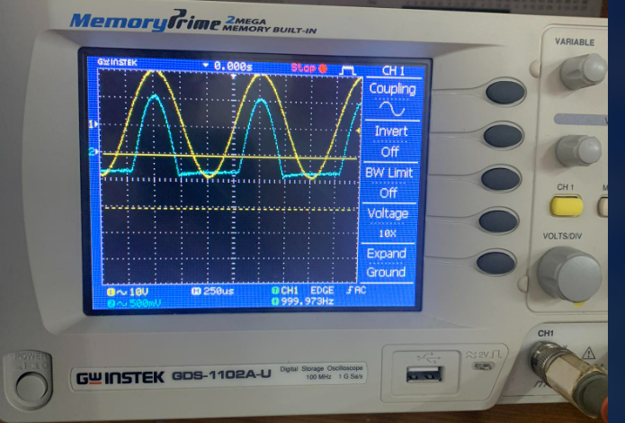

Electronics Devices Page 8 of 9
INTERNATIONAL UNIVERSITY
SCHOOL OF ELECTRICAL ENGINEERING (EE)

In most of applications, a transformer is used to scale the input voltage. To build a power supply, for example, the 220V AC signal would be reduced to 10V AC signal using a transformer. The output of the transformer would be a sinusoidal signal with 10V peak amplitude, which is just like the one generated by the function generator in this lab.

Useful hints:
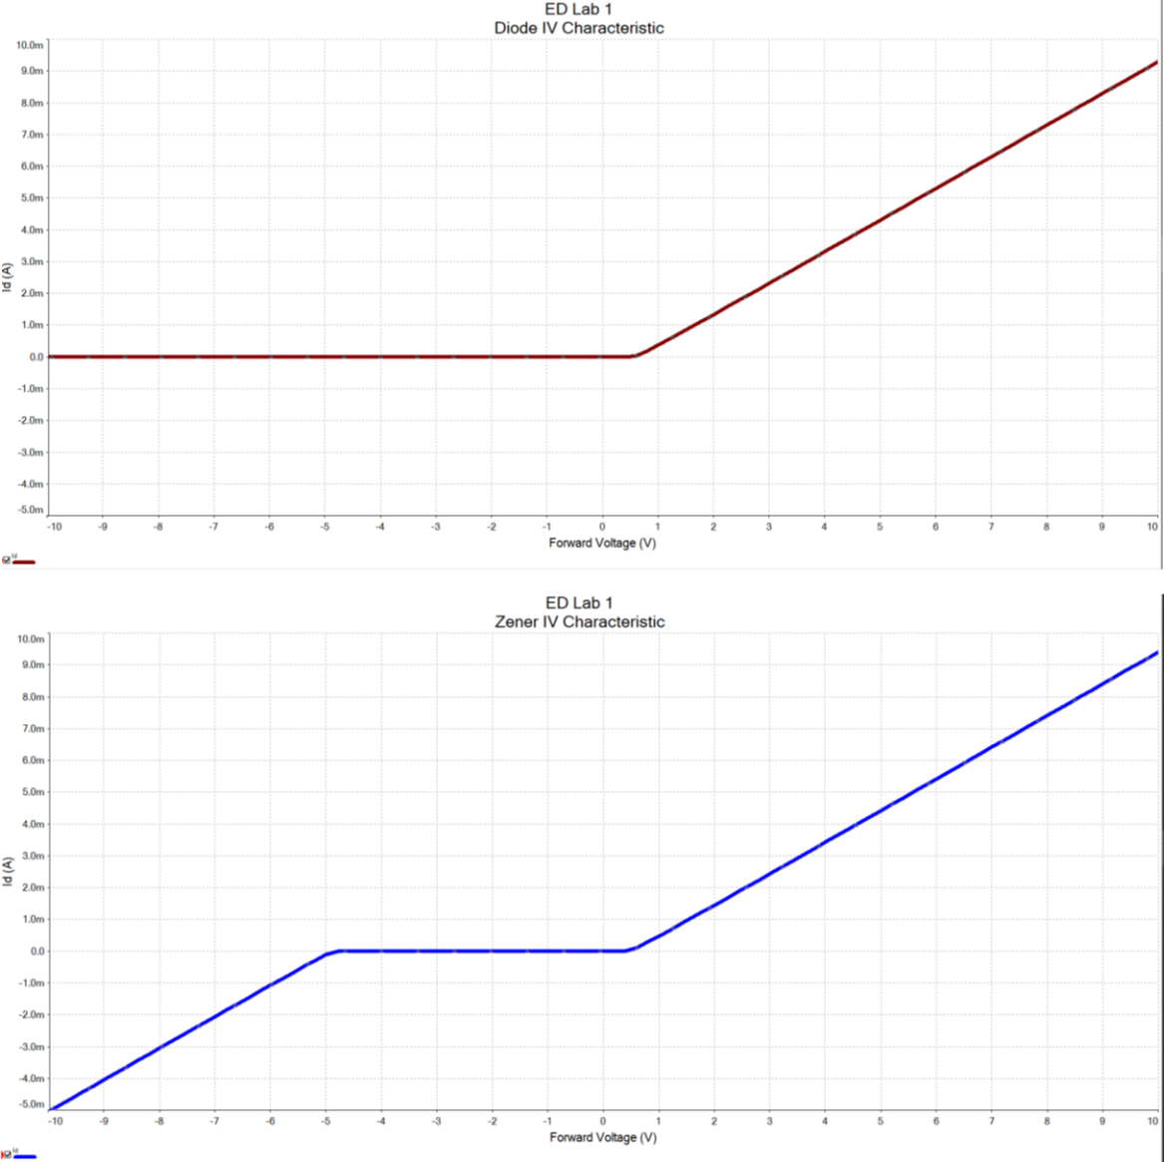

Electronics Devices Page 9 of 9

